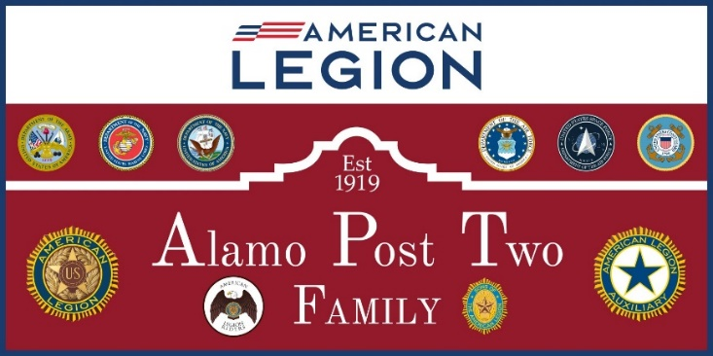

General Membership Meeting Minutes
April 2, 2024

Meeting was called to order by Commander Albert Mireles Jr at 6:30 P.M. The standard opening ceremony was conducted.
Adjutant Allen Iott called the roll of Officers and Executive Committee members. Called for a quorum were:
Post Officers: Post Executive Committee Members:
- Commander, Albert Mireles Jr Present 1. Carlos Salazar Present
- 1st Vice Commander, Pat Farrell Present 2. Al Anderson Absent
- 2nd Vice Commander Michael Knott Present 3. Hermlinda Zavala Absent
- Judge Advocate, Ricardo Munoz Absent 4. Debra Sackett Absent
- Adjutant, Allen G. Iott Excused 5. Andrea Ortiz Absent
- Finance Officer, Carlos Mendez Excused
- Service Officer, Eddie Tello Absent
- Historian, Dan Almendarez Absent
- Sgt-At-Arms, Todd Griffin Present
- Asst Sgt-At-Arms, Daniel Rodriguez Absent
11. Chaplain, Yehoshua Huerta Present

Quorum was present to conduct business.

General Membership minutes and Executive Committee minutes were handed out to the membership present prior to the meeting. Motion was presented by Todd Griffin and seconded by Robert Anton to approve minutes. Motion was voted upon and passed.

The following guests were present at the meeting: New member Scott introduced himself.

COMMITTEE REPORTS

First Vice Commander reported that the Post is currently at 641 renewals which is 95% of the goal for the 2024 membership year of 674.

Second Vice Commander reported that there 9 boys from Central Catholic going to Boys State and he is working with the school on funding. He also the membership if anyone was willing to sponsor a boy for Boys State.

Finance Officer No report.

Adjutant No report.

Chaplain: No report.

Judge Advocate No report.

Post Service Officer: No report.

Historian No report

Standing Committees:

Building and House Committee Chairman: reported that the flooring for the ballroom is delayed due to shipping with installation looks to take place by the end of May. AC units were serviced with 2 for the ballroom with one at 65% operation and the other is at 100% operation. The AC in the canteen was inoperable and has since been repaired and functional.

Budget and Finance Committee Chairman No report

Color Guard No Report

Scouting: No report

Sons of the American Legion (SAL): No report

Legion Rider Chairman No report

Public Affairs/Hubmaster Committee Chairman No report.

UNFINISHED BUSINESS

None

NEW BUSINESS
Resolution for Adjutant Allen Iott to be selected as 20th District Adjutant was read and motion was made for approval Pat Farrell and seconded by Todd Griffin. Motion passed.

The following nominations for officer positions in the Post Elections scheduled for the May General meeting:

Commander: Albert Mireles was nominated by Suzzie Thomas and seconded by Pat Farrell. Albert Mireles accepted.
1st vice-Commander: Pat Farrell was nominated by Michael Knott and seconded by Todd Griffin. Pat Farrell accepted.
2nd Vice-Commander: Michael Knott was nominated by Pat Farrell and seconded by Robert Anton. Michael Knott accepted.
Finance Officer: Carlos Mendez was nominated by Michael Knott and seconded by Pat Farrell.
Adjutant: Allen Iott was nominated by Pat Farrell and seconded by Robert Anton.
Chaplain: Yehoshua Huerta was nominated by Michael Knott and seconded by Pat Farrell but declined the nomination.
Sgt-at-Arms: Todd Griffin was nominated by Pat Farrell and seconded by Michael Knott but declined the nomination.

The following positions need nominations: Chaplain, Sgt-at-Arms, Service Officer, Historian, and Executive Committee members (5). Nominations for all office positions can be taken from the floor at the May General meeting.

FOR THE GOOD OF THE LEGION
Fish Fry will be held on the first Friday of the month with the other Fridays having a themed event such as Birthday dance.

Saturday, April 6 will be the Pre-Fiesta dance, there will be concession stand at these events let by Pat Farrell in the kitchen.

The 3rd Annual Women Veterans Luncheon will be held on 20 April in the ballroom.

From The American Legion National Commander Daniel J. Seehafer: “The American Legion is a family . organization that is changing lives through our programs and saving lives by welcoming veterans and helping those hurt. Be the One!”

Reminder to all members of the Post of what the Four Pillars and programs of the American Legion are about. The Post is not a bar or dance hall. We need these activities to fund these programs. Remember who we are and the mission.

ADJOURNMENT
There being no further business to come before the meeting, the Chaplain offered the closing prayer.
The meeting was adjourned by the Commander at 1855 hours.

Prepared by:
Allen Iott Alamo Post 2 Adjutant

