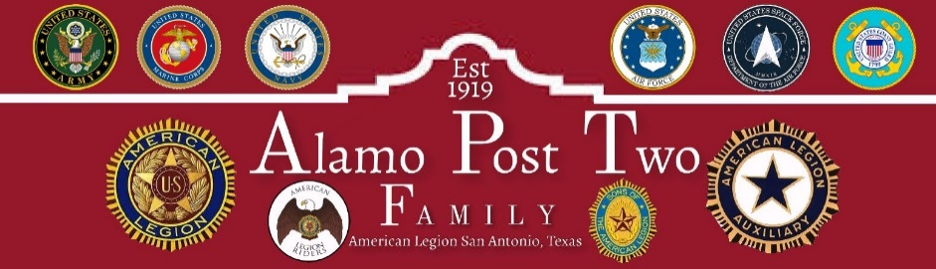

Executive Membership Meeting Minutes
May 28, 2024

Meeting was called to order by Second Vice-Commander Pat Farrell at 6:30 P.M. The standard opening ceremony was conducted.
Adjutant Allen Iott called the roll of Officers and Executive Committee members. Called for a quorum were:
Post Officers: Post Executive Committee Members:
- Commander, Albert Mireles Jr Present 1. Carlos Salazar Present
- 1st Vice Commander, Pat Farrell Present 2. Al Anderson Absent
- 2nd Vice Commander Michael Knott Present 3. Hermlinda Zavala Absent
- Judge Advocate, Ricardo Munoz Absent 4. Debra Sackett Absent
- Adjutant, Allen G. Iott Present 5. Andrea Ortiz Absent
- Finance Officer, Carlos Mendez Present
- Service Officer, Eddie Tello Absent
- Historian, Dan Almendarez Absent
- Sgt-At-Arms, Todd Griffin Present
- Asst Sgt-At-Arms, Daniel Rodriguez Absent
11. Chaplain, Yehoshua Huerta Absent

There being 7 of 14 current members of the Executive Committee present a quorum was present to conduct business.

There were the following guests in attendance: Robert Villaran, Eduardo Garcia, Rosie Mendez, Dee Mireles

COMMITTEE REPORTS

First Vice Commander
None

Second Vice Commander We have a total of 11 Boys State Statesmen going to TX Boys State.

Finance Officer No report.
Adjutant Allen Iott reported the possibility of the Post nominating employers who have veterans as employees for awards through Department and National. This is in addition to our nominations for Police, Fire, Paramedic, and Reserve/National Guard award program.

Judge Advocate No report.

Historian No report

Chaplain Report No report.

Service Officer No report.

Standing Committees:

House Committee Chairman: No report

Budget and Finance Committee Chairman No Report

Color Guard Event No report.

Legion Rider Chairman No report

Public Affairs/Hubmaster Committee Chairman: No report.

Alamo Band Director: No report

Building and Grounds Committee Chairman No Report

UNFINISHED BUSINESS

None

NEW BUSINESS
Commander Mireles outlined his objectives and goals for the year 2024-2025 by concentrating on the Four Pillars of The American Legion: Children and Youth, Veteran Affairs and rehabilitation, Americanism, and National Security. He also reminded the officers of their primary and secondary duties. He also directed some of the committees to be used and chaired by the Executive Committee members: Eduardo Garcia, Robert Villagran, Carlos Salazar, Carlos Mendez and Laleche Seay. The committees in his vision are House Committee with the concern of running the kitchen, main hall and canteen and overall management of the Enterprise nature of the Post with the chairman as Robert Villagran and Carlos Salazar.
Building committee dealing with the repairs and the structure of the building.
Budget committee to include the acting finance officer (Carlos Mendez) and oversee the finance and income of all aspects of the Post.
Post Event Fundraising committee to include the recently commissioned POW/MIA scholarship fund.
Bingo Committee to attend lottery commission meeting and send quarterly bingo report.
Veterans Group committee which will coordinate with other veterans’ groups to assist veterans and recognize veterans for their efforts.

FOR THE GOOD OF THE LEGION
ADJOURNMENT
There being no further business to come before the Executive Committee the Commander adjourned the meeting at 1930 hrs.

